|  |  |
| --- | --- |
|  |  |

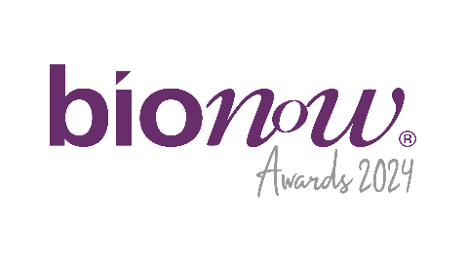

Bionow Annual Awards 2024

Application Form – Bionow Rising Star Award

# Nominations are invited on behalf of individuals working in the life science sector. The competition is open to all career paths within the sector (including but not limited to research, manufacture, QA/QC, academia, management, business development etc).

# The Bionow Rising Star Award will be presented to an exceptional individual who satisfies the following conditions:

* Works for a company, organisation or research institution which operates in, or for, the life sciences sector.
* Are within the first 5 years of their life sciences career or shortly following a career break or change.

**The competition will be judged on:**

* Quality of the individual’s approach to develop scientific understanding, a new product, service or business offering.
* Novelty of approach by the individual, innovation and enterprise in terms of commercial potential and the approach to commercialisation.
* Further developments from an original project, or new ones because of the individual’s work.
* Leadership and business development skills.

Please complete the application form below, ensuring that all fields are completed and any additional documentation that is required to support the application is attached.  
  
**Applications should be sent to** [**awards@bionow.co.uk**](mailto:awards@bionow.co.uk) **ensuring that the subject line of your email clearly indicates the award category that you are applying for.**  
  
**Closing date:** Thursday 16th January 2025

Please note that there will be no extension given to this deadline.

All information provided will be treated in confidence and only distributed to the judging panel for use in this competition. The judging panel will consist of one invited representative from each of the award sponsor organisations plus representatives of Bionow. The decision of the panel will be by majority and is final.

|  |  |
| --- | --- |
| Nominator Details | |
| Name |  |
| Position |  |
| Company |  |
| Address |  |
| Postcode |  |
| Telephone |  |
| Email |  |
| Nominee Details | |
| Name |  |
| Position |  |
| Company |  |
| Address |  |
| Telephone |  |
| Email |  |
| Summary of nominee’s achievements/career (Max 50 words).  If shortlisted this profile will be featured within the Awards brochure |  |
| In less than 400 words, please describe why you think the Nominee should win this award (supporting information is also welcomed but please limit to 3-4 pages maximum) | |