|  |  |
| --- | --- |
|  |  |

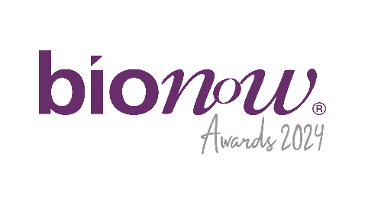

Bionow Annual Awards 2024

Application Form – Bionow Partnership and Collaboration Award

# Applications are invited from and on behalf of organisations and businesses in the life sciences sector that have achieved a significant commercial outcome through a collaboration or partnership. Thus should involve at least one life sciences industry partner plus at least one other partner from academia, NHS, charity, third sector or industry.

# The Bionow Partnership and Collaboration Award will be presented to a partnership or collaboration that can demonstrate it satisfies the following conditions:

* Involves at least one life sciences industry partner plus at least one other partner from academia, NHS, charity, third sector or industry.
* Is aimed at manufacture, research, development and/or commercialisation of products, services or technologies within the life-science sector.
* Is aimed at creating value or progressing towards commercial success as a result of the collaboration.

**The competition will be judged on:**

* How the collaboration or partnership demonstrates innovation towards commercial success.
* The activity undertaken by all the partners and how they have worked together effectively.
* The nature of the partnership and what all parties brought to the partnership.
* The commercial and wider outputs of the partnership.

Please complete the application form below, ensuring that all fields are completed and any additional documentation that is required to support the applications is attached.

**Applications should be sent to** [**awards@bionow.co.uk**](mailto:awards@bionow.co.uk) **ensuring that the subject line of your email clearly indicates the award category that you are applying for.**

**Closing date:** Thursday 16th January 2025

Please note that there will be no extension given to this deadline.

All information provided will be treated in confidence and only distributed to the judging panel for use in this competition. The judging panel will consist of one invited representative from each of the award sponsor organisations plus representatives from Bionow. The decision of the panel will be by majority and is final.

|  |  |
| --- | --- |
| Applicant Details | |
| Name |  |
| Title |  |
| Position |  |
| Organisation |  |
| Address |  |
| Postcode |  |
| Telephone |  |
| Email |  |
| Collaboration/Partnership Details | |
| Collaboration / Partnership Name  **(Max 10 words)** |  |
| Names of partners / collaborators and contribution of each |  |
| Period of partnership / collaboration |  |
| Outputs |  |
| Summary of collaboration / partnership  **(Max 50 words)** If shortlisted this profile will feature within the Awards brochure |  |
| In less than 400 words, please describe why this partnership or collaboration fulfils the award criteria and should win this award. Each application **MUST** be supported by appropriate documentation to demonstrate the partnership or collaboration and its outputs to allow the judging panel to assess its merit towards winning this award. | |