|  |  |
| --- | --- |
|  |  |
|  |  |

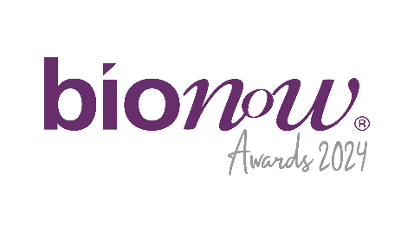

Bionow Annual Awards 2024

Application Form – Bionow Internationalisation Award

Applications are invited from and on behalf of companies or organisations who are trading their products, services and expertise overseas and they believe fulfil the award criteria below.   
  
**The Bionow Internationalisation Award will be presented to a company that satisfies the following conditions:**

* Is an innovative life sciences organisation either involved in manufacture, research and development or the provision of goods/services to the life-science sector.
* Can clearly demonstrate internationalisation successes such as increased export sales, new international locations, identification of new markets, new products and services including clinical trials.
* Can demonstrate a strategy employed over a period of time leading to increased internationalisation.

**The competition will be judged on:**

* Current and future internationalisation and strategy execution.
* Growth in internationalisation including export sales.
* Creativity and innovation that has led to success.
* Barriers that the company has encountered and overcome.

Please complete the application form below, ensuring that all fields are completed and any additional documentation that is required to support the application is attached.

**Applications should be sent to** [**awards@bionow.co.uk**](mailto:awards@bionow.co.uk) **ensuring that the subject line of your email clearly indicates the award category that you are applying for.**

**Closing date:** Thursday 16th January 2025

Please note that there will be no extension given to this deadline.

All information provided will be treated in confidence and only distributed to the judging panel for use in this competition. The judging panel will consist of one invited representative from each of the award sponsor organisations plus representatives from Bionow. The decision of the panel will be by majority and is final.

|  |  |
| --- | --- |
| Applicant Details | |
| Name |  |
| Title |  |
| Position |  |
| Company/Institution |  |
| Address |  |
| Postcode |  |
| Telephone |  |
| Email |  |
| Application Details | |
| Date company started internationalisation journey |  |
| Product / Service |  |
| Turnover from international markets |  |
| Percentage of international sales |  |
| Details of growth in international activity over recent years |  |
| Barriers that the company has overcome |  |
| Internationalisation details  **(Max 50 words)** If shortlisted this profile will feature within the Awards brochure |  |
| In less than 400 words, please describe why the company fulfils the award criteria and should win this award. Each application **MUST** be supported with an internationalisation strategy/business strategy / business plan or other appropriate documentation which addresses the award criteria above, and allows the success with exporting and the current and future strategy, to be determined by the judging panel. | |