|  |  |
| --- | --- |
|  |  |

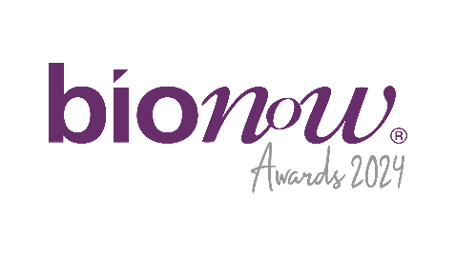

Bionow Annual Awards 2024

Application Form – Bionow Business Support Award

# Applications are invited from and on behalf of companies or organisations which fulfil the following award criteria.

# The Bionow Business Support Award will be presented to a company that satisfies the following conditions:

* Are an organisation with a large part of their activities involved in supporting the life sciences sector.
* Can demonstrate exceptional support, tangible results and feedback from clients they have worked with.
* Demonstrates the commitment, professionalism, creativity and success of support to businesses in the life sciences sector.

**The competition will be judged on:**

* Commercial success (e.g. economic growth/turnover; deals done; collaborations and partnerships established, grants secured, investment raised to date).
* Understanding customers’ needs, quality of support and contribution to client success.
* Making a difference to the growth of the life science sector.
* The degree of innovation surrounding the support.

Please complete the application form below, ensuring that all fields are completed and any additional documentation that is required to support the applications is attached.

**Applications should be sent to** [**awards@bionow.co.uk**](mailto:awards@bionow.co.uk) **ensuring that the subject line of your email clearly indicates the award category that you are applying for.**   
  
**Closing date:** Thursday 16th January 2025  
Please note that there will be no extension given to this deadline.

All information provided will be treated in confidence and only distributed to the judging panel for use in this competition. The judging panel will consist of one invited representative from each of the award sponsor organisations plus representatives from Bionow. The decision of the panel will be by majority and is final.

|  |  |
| --- | --- |
| Applicant Details | |
| Name |  |
| Title |  |
| Position |  |
| Organisation |  |
| Address |  |
| Postcode |  |
| Telephone |  |
| Email |  |
| Support Details | |
| Support Name  **(10 words max)** |  |
| Launch Date |  |
| Development Time |  |
| External Collaborators  (if any) |  |
| Route to Market/Business Model |  |
| Impact of support on life sciences sector |  |
| Description of Support (max 50 words).  If shortlisted this profile will feature in the Awards brochure |  |
| In less than 400 words, please describe why this support fulfils the award criteria and should win this award. Supporting documentation which addresses the award criteria above and demonstrates the services provided and/or case studies which allows the quality and innovation of the services to be determined **MUST** also be provided. | |