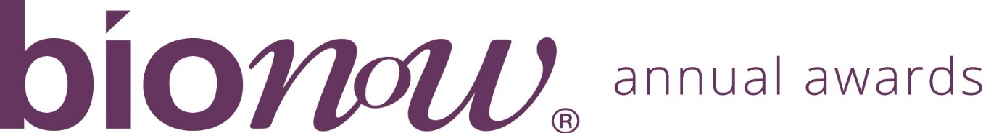
Bionow Annual Awards 2019
Application Form – Bionow Technical Service Award

Applications are invited from and on behalf of specialist biomedical service companies or organisations which fulfil the award criteria.

The Bionow Technical Service Award will be presented to a company that can demonstrate its specialist technical service satisfies the following conditions:

- Falls within the definition “the use of innovative approaches to develop biomedical services, equipment or products particularly those which serve the needs of human healthcare”
- Demonstrates an innovative solution to a particular problem encountered within the industry
- Demonstrates the commitment, professionalism, creativity and success of support to businesses in the biomedical sector
The competition will be judged on:
- Impact of the service on the problem which it addresses;
- Quality of the service;
- Degree of innovation surrounding the technical service and/or business model followed;
Please complete the application form below, ensuring that all fields are completed and any additional documentation that is required to support the applications is attached.
Application should be sent to awards@bionow.co.uk ensuring that the subject line of your email clearly indicates the award category that you are applying for.
Closing date: 5.30pm on Friday 25th October 2019
Please note that there will be no extension given to this deadline
All information provided will be treated in confidence and only distributed to the judging panel for use in this competition. The judging panel will consist of one invited representative from each of the award sponsor organisations plus from Bionow. The decision of the panel will be by majority and is final.

Applicant Details
Name
Title
Position
Company/Institution
Address
Postcode
Telephone
Email

Service Details
Service Name
(Max 10 words)
Launch Date
Development Time
External Collaborators
(if any)
Route to Market/Business Model
Market Size
Summary of Service
(Max 50 words)
If shortlisted this profile will feature within the Awards brochure
In less than 400 words, please describe why this service fulfils the award criteria and should win this award. Each application MUST be supported by appropriate documentation to demonstrate the technical services provided and/or case studies which allows the quality and innovation of the services provided to be determined by the judging panel.

